|  |  |
| --- | --- |
| **Midterm Project Report** | |
| Student ID: 110061644 | Name: 梁謙行 |

1. Questions (Brief and concise explanation of one to two pages would be enough. You may use Chinese.)

* How do you design your accelerator? Please draw the FSM and block diagram to  
  explain the overall architecture. (2%)

Ans:

在ACC中我使用了40個MAC來做運算，在做convolution時先read八個data進到buffer裡面，然後分別送到四組MAC，累加五次算出一個convolution的點，下方的圖為四組MAC，總共要有八組，前四組會做1~5列的activation*mask的累加，後四組會做2~6列的activation*mask的累加，

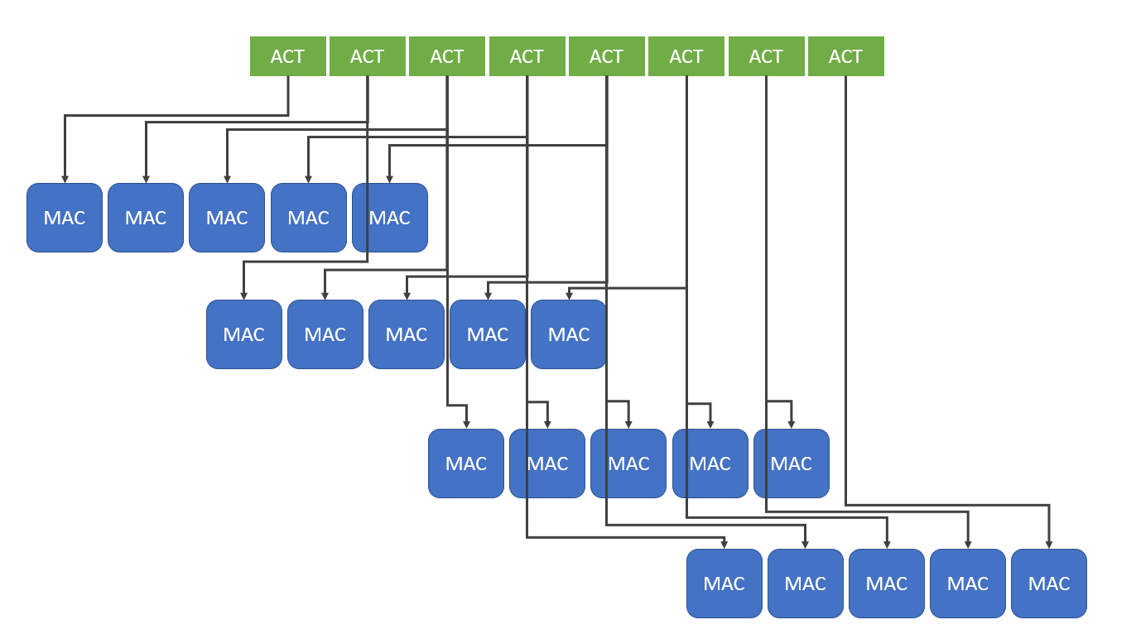

每一組MAC後面有adder tree將五個值加總起來，再將四個result做pooling，再quantize並存入write buffer寫回sram，

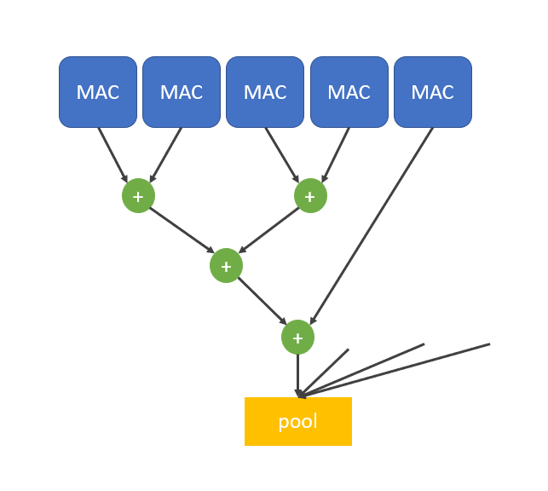

Fully connected layer時使用八個MAC  
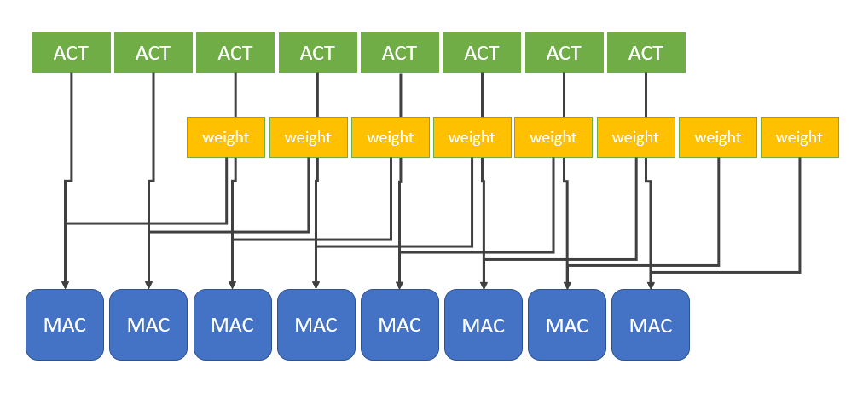

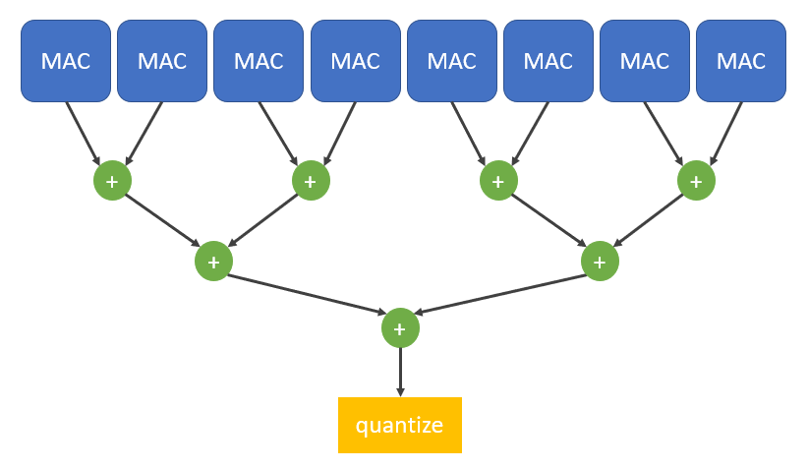

FSM

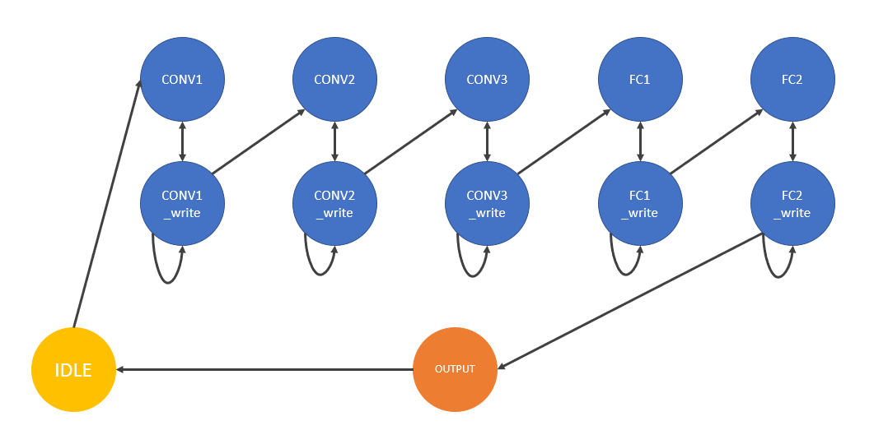

* How do you design your DMA controller interface to transfer data? Please draw the block diagram and FSM. (2%)

Ans:

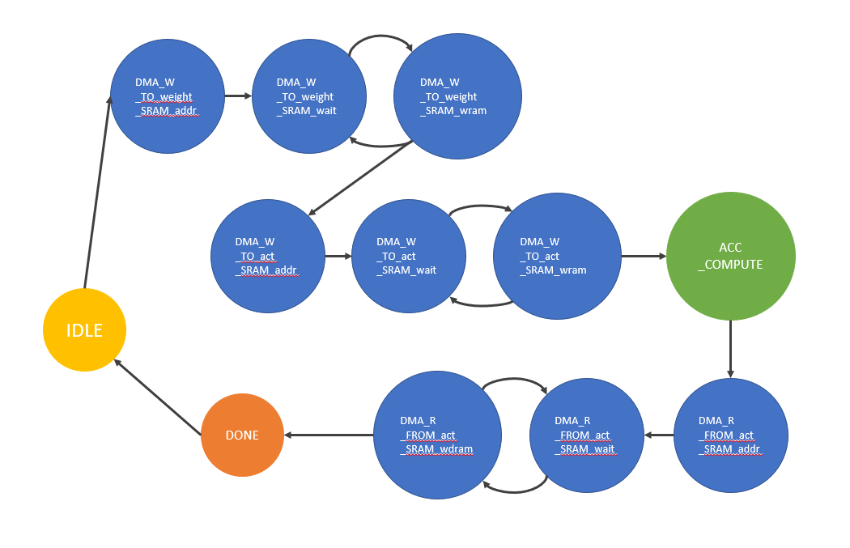

* How do you build two SRAMs in this project? Please draw the block diagram.(2%)

Ans:

Weight SRAM (32 BRAM)

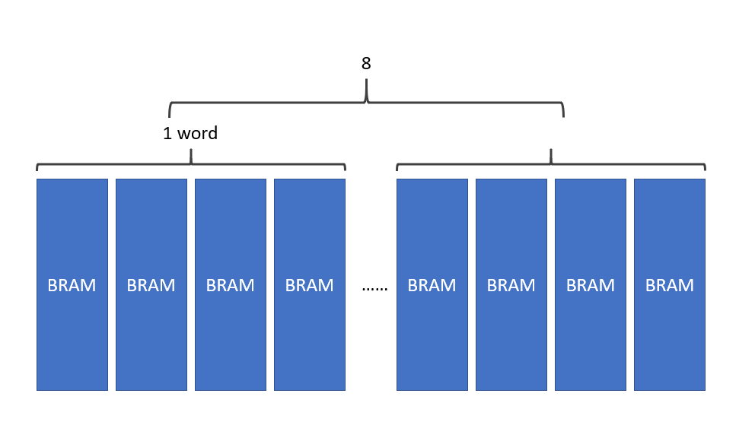

Activation SRAM (4 BRAM)

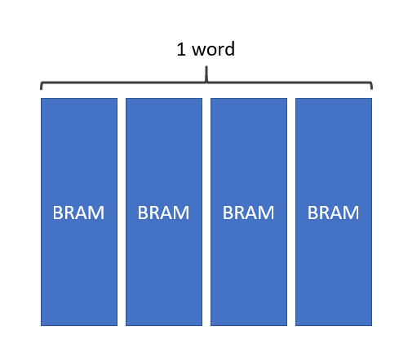

* Please briefly explain why we write images from mem[20000] to mem[20255], but read images from address 10000 to address 10127 in the accelerator? (2%)

Ans:

* What is the function of the following code? (1%)

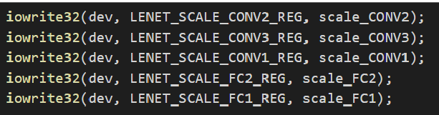

Ans:

將lenet.c裡面設定的scaling factor寫入platform中的電路裡面，此時可以看到modelsim裡的波型scaling factor從零轉變為指定的值。

* What is the function of the following code? Please explain line by line (1%)

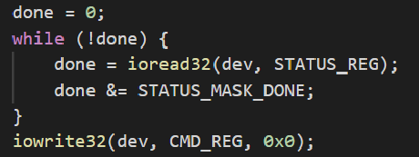

Ans:

先將done設為零，並進入while迴圈，只要done依然為零就會不斷執行while迴圈，再回圈中會不斷讀取platform中done register的值，若讀到1就會跳出迴圈，代表accelerator完成動作。

1. Result

|  |  |  |
| --- | --- | --- |
| Item | Description | Unit |
| RTL simulation | PASS:  IMAGE,CONV1,CONV2,CONV3  FAIL:  FC1,FC2  我發現再從DMA從DRAM搬weight資料到SRAM裡的時候，當寫到address[9:1] = 9’b111111111  時無法成功寫入資料sram裡的data還是為0，來不及找出原因，但這要到FC1以後問題才出現，所以還是可以通過CONV1,2,3。 | --- |

1. Others (optional)

* Suggestions or comments about this class to teacher or TA.